Point and Line Duality: NOTES 2

* Radius 4000
* Source (0,0) and Destination (0,4000)
* Y coordinates are from [-60,0]. Length 60

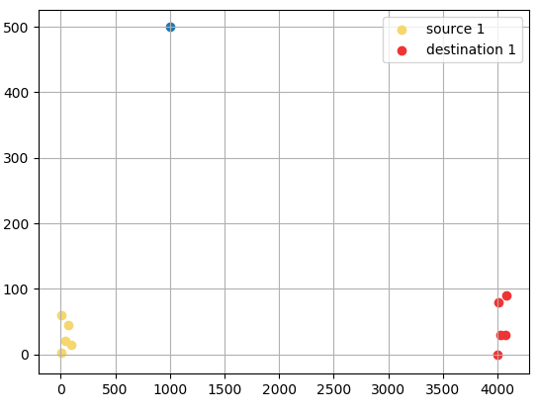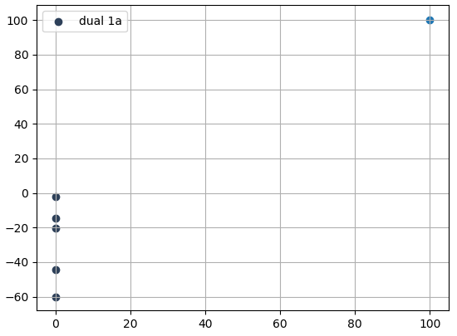

* Radius 4500
* Source (4000,0) and destination (8500,0)
* Y coordinates are from [-87.5,70]. Length 60

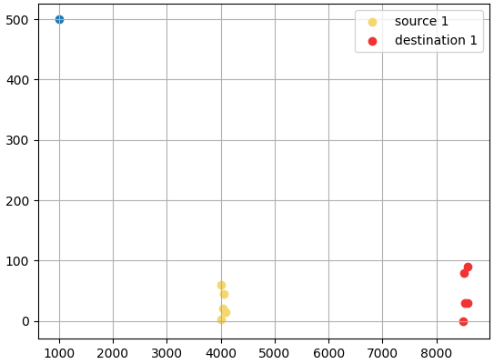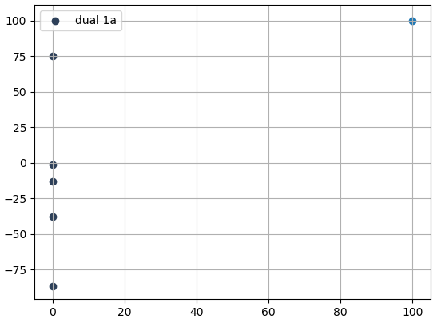

* Source1 (0,0) and destination1 (4000,0)
* Y coordinates for dual 1 are from [-60,0]. Length 60
* Source2(4500,0) and destination2(8500,0)
* Y coordinates for dual2 are from [-87.5,100]. Length 187.5
* These rides should not be grouped together
* The spread of dual 2 is greater as compared to dual1.
* Here the end points of dual2 are far apart from the end points of dual 1.
* Distance of 100 and 40

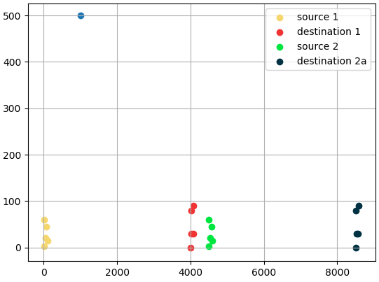 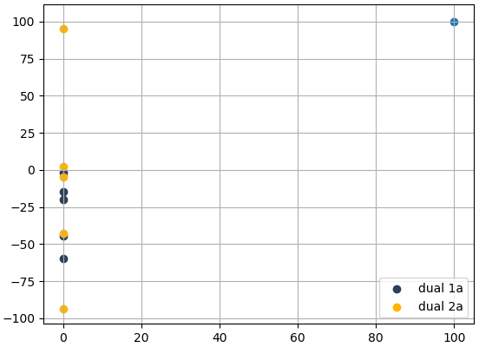

* Source1 (0,0) and destination1 (4000,0)
* Y coordinates for dual 1 are from [-60,0]. Length 60
* Source2(0,0) and destination2(3941.317,693.67)
* Y coordinates for dual2 are from [-60,5]. Length 187.5
* The distance between the y coordinates is almost 696 so these rides can be grouped together.
* These rides could be grouped together.
* The spread of dual 1 and dual 2 is almost the same.
* They differ in x axis by 0.2

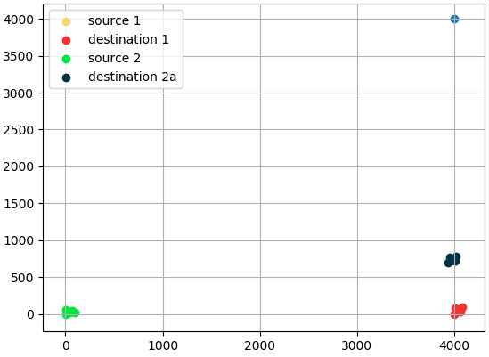 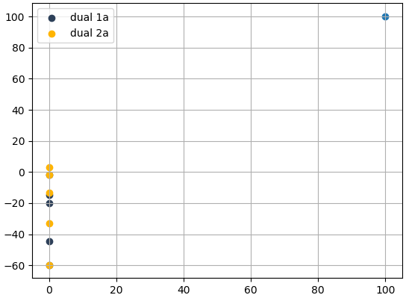

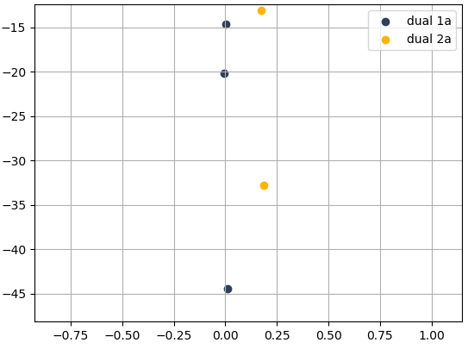

* Source1 (0,0) and destination1 (4000,0)
* Y coordinates for dual 1 are from [-60,0]. Length 60
* Source2(0,0) and destination2(3941.317,693.67)
* Y coordinates for dual2 are from [-60,5]. Length 65
* Source3(0,0) and destination3(3761.21,1365.3)
* Y coordinates for dual3 are from [-20,60]. Length 80
* The angle between OD1 and OD2 is 10 degrees.
* The distance between D1 and D2 is 696. The can be grouped together
* The angle between OD1 and OD3 is 20 degrees.
* The distance between D1 and D3 is 1386. Should these be grouped together?
* The angle between OD2 and OD3 is 10 degrees
* The distance between D2 and D3 is 696. These 2 can be grouped together.

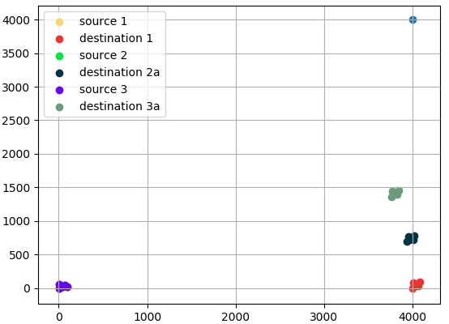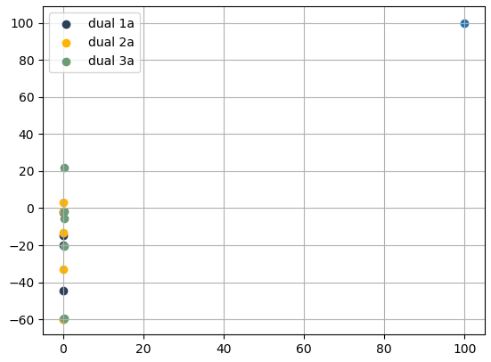

* In the Y axis the spread is similar for OD1, OD2 and OD3
* In the X axis the distance between dual1 and dual2 is around 0.2
* The distance between dual1 and dual2 is 0.2
* The distance between dual2 and dual3 is 0.2
* The distance between dual1 and dual3 is 0.4

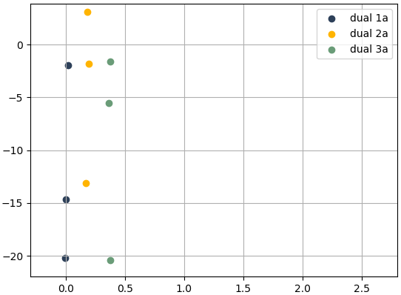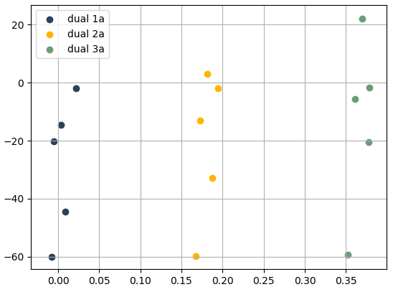

* Source1 (0,0) and destination1 (3468.43,2001.28)
* Source2(0,0) and destination2 (2828,2828)
* Y coordinates for dual1 are from [-60,40]
* Y coordinates for dual2 are from [-60,80]
* OD1 is at 30 degrees from the x axis
* OD2 is at 45 degrees from the y axis
* The distance between D1 and D2 is 1046? Can they be grouped together?
* The distance between dual1 and dual2 is 0.4

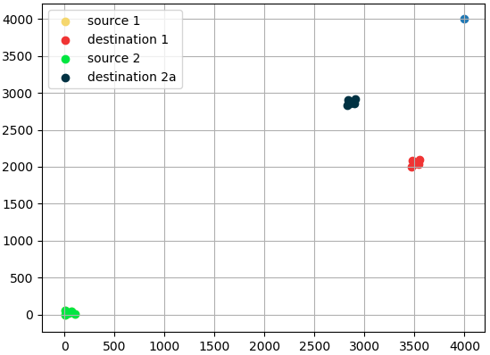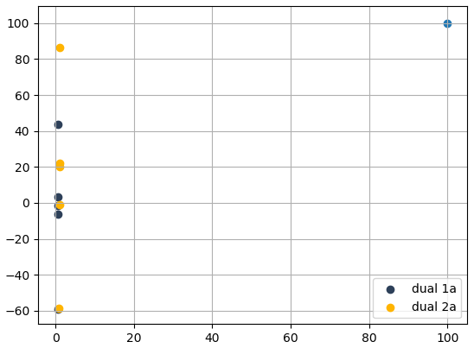

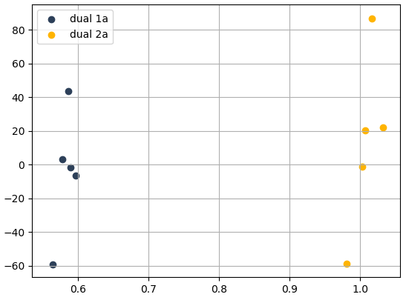

* Source1 (0,0) and destination1 (3468.43,2001.28)
* Source2(0,0) and destination2 (2828,2828)
* Source3(0,0) and destination3 (3067.85, 2546.32)
* OD1 is at 30 degrees from x axis
* OD2 is at 40 degrees from x axis
* OD3 is at 45 degrees from the x axis
* Distance between D1 and D3 is 676. They can be grouped together.
* The distance between D2 and D3 is 370. They can be grouped together.
* D1 and D2 might not get grouped together.
* Y coordinates for dual1 are from [-60,40]
* Y coordinates for dual2 are from [-60,80]
* Y coordinates for dual2 are from [-60,70]
* The end points of dual3 and dual2 are close together at about 20. The end point of dual1 is farther. It can’t be grouped together with dual3 and dual2

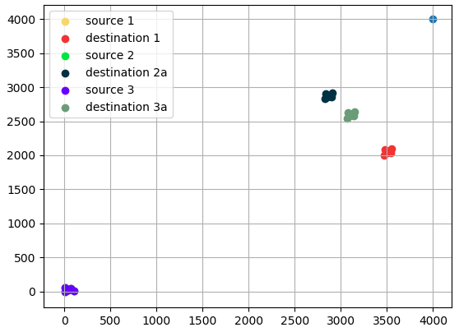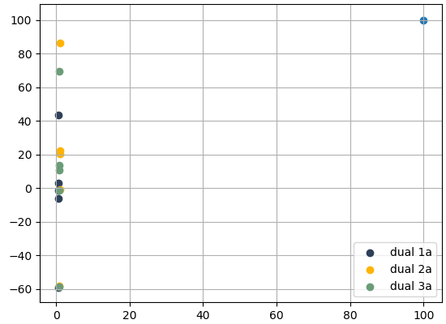

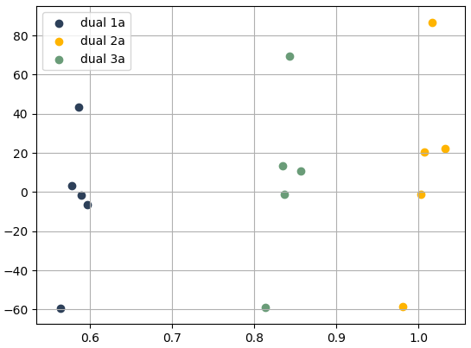

* Source1 is at (0,0) and Destination1 is at (4000,0)
* Source2 is at (2000,0) and Destination2 is at (6000,0)
* Dual1 ranges from [-60,0]. Length is 60
* Dual2 ranges from [-75,40]. Length is 115
* Distance between the top end points is 40
* Distance between the bottom end points is 15

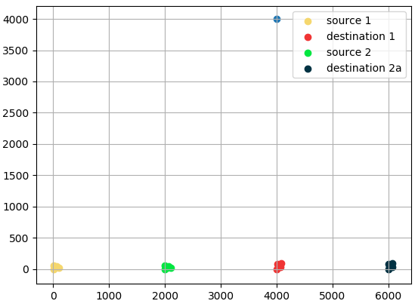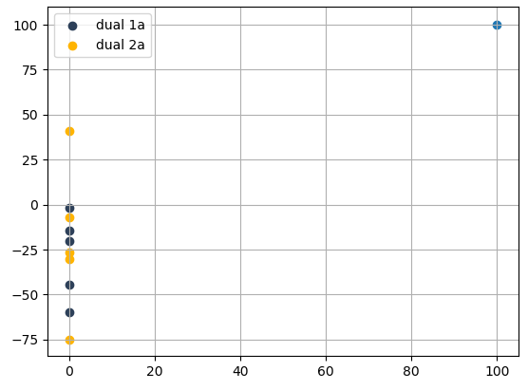

* Source1 is at (4000,0) and Destination1 is at (8000,0)
* Source2 is at (6000,0) and Destination2 is at (10000,0)
* Dual1 ranges from [-90,85]. Length is 175
* Dual2 ranges from [-105,125]. Length is 230
* Distance between the top end points is 45
* Distance between the bottom end points is 15

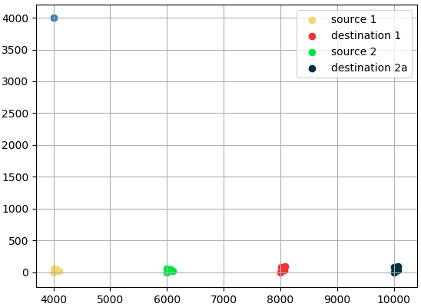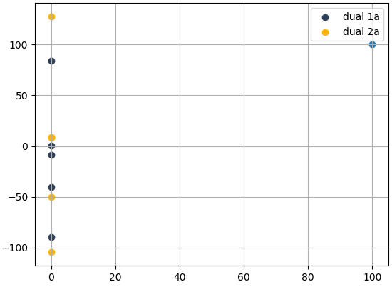

* Source1 is at (8000,0) and Destination1 is at (1200,0)
* Source2 is at (10000,0) and Destination2 is at (14000,0)
* Dual1 ranges from [-115,170]. Length is 285
* Dual2 ranges from [-135,215]. Length is 350
* Distance between the top end points is 45
* Distance between the bottom end points is 15

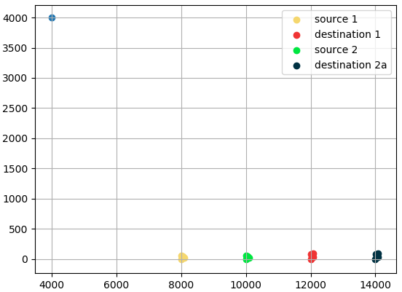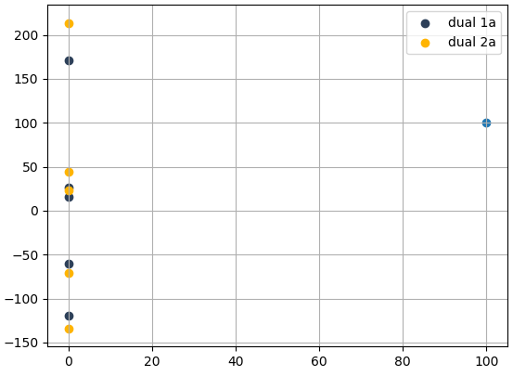

* Source1 is at (8000,0) and Destination1 is at (1200,0)
* Source2 is at (10000,0) and Destination2 is at (14000,0)
* Source3 is at (4000,0) and Destination3 is at (7000,0)
* Dual1 ranges from [-120,170]. Length is 290
* Dual2 ranges from [-135,215]. Length is 350
* Dual3 ranges from [-100,110]. Length is 210
* Distance between the top end points of dual1 and dual2 is 45
* Distance between the bottom end points dual1 and dual2 is 15
* Distance between the top end points dual1 and dual3 is 70
* Distance between the bottom end points dual1 and dual3 is 20
* Distance between the top end points dual1 and dual2 is 105
* Distance between the bottom end points dual1 and dual2 is 35

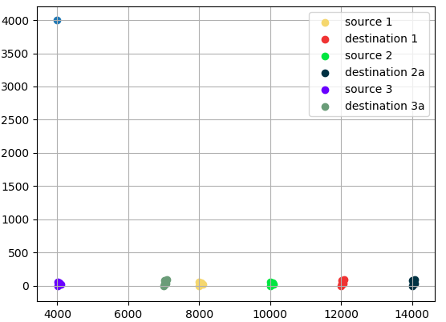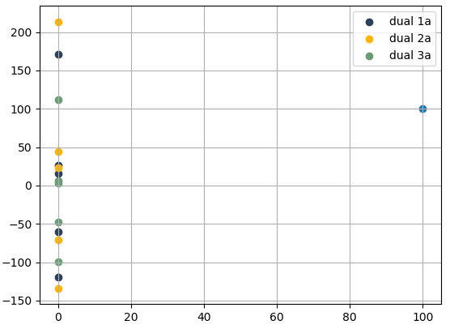

* Source1 is at (12000,0) and Destination1 is at (16000,0)
* Source2 is at (14000,0) and Destination2 is at (18000,0)
* Dual1 ranges from [-150,260]. Length is 410
* Dual2 ranges from [-165,300]. Length is 465
* Distance between the top end points is 40
* Distance between the bottom end points is 15

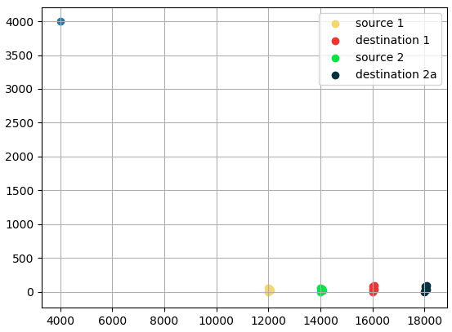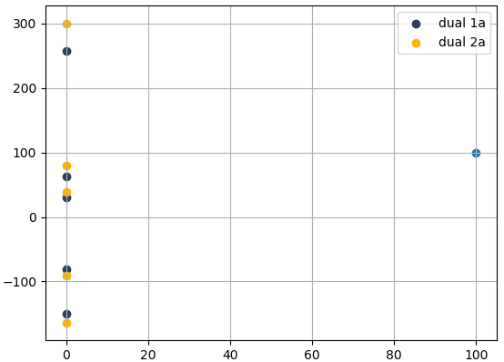

* Source1 is at (0,0) and Destination1 is at (400,0)
* Source2 is at (3500,0) and Destination2 is at (7500,0)
* Dual1 ranges from [-60,0]. Length is 58
* Dual2 ranges from [-85,75]. Length is 160
* Distance between the top end points is 75
* Distance between the bottom end points is 25

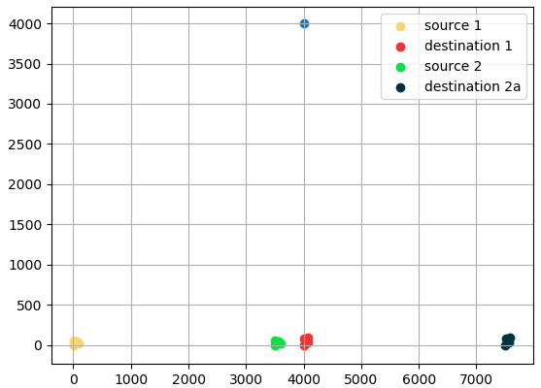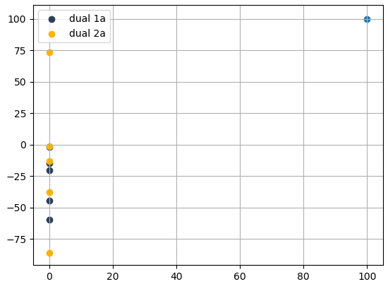

* Source1 is at (8000,0) and Destination1 is at (12000,0)
* Source2 is at (11500,0) and Destination2 is at (15500,0)
* Dual1 ranges from [-120,250]. Length is 400
* Dual2 ranges from [-145,250]. Length is 155
* Distance between the top end points is 80
* Distance between the bottom end points is 25

